1.1.3 Area of square
Algorithm
Step 1 :- Start
Step 2 :- Read the side length of the square.
Step 3 :- Calculate the area using the formula
Step 4:- $\text{area}={\text{side_length}}^{2}$
Step 5 :- Display the area.
Step 6 :- Stop
Flowchart
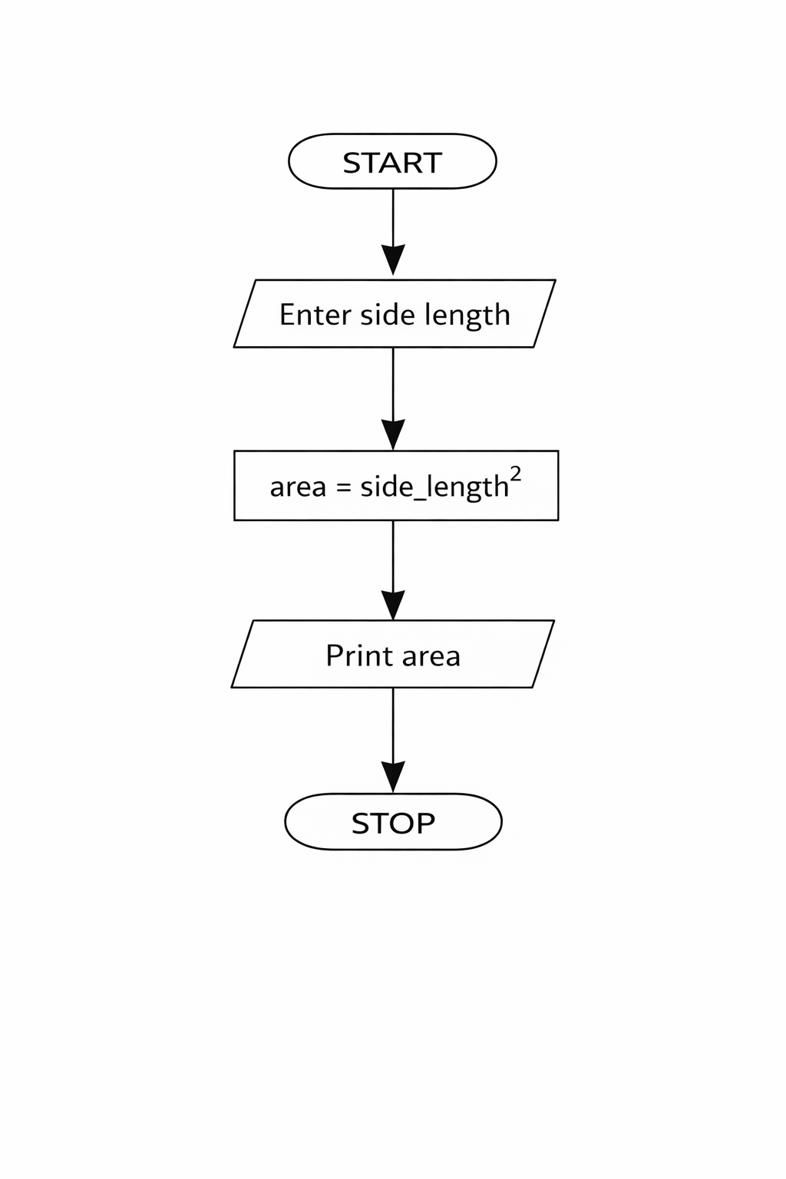
Python code
side_length = int(input())
area = side_length ** 2
print(area)

EXCECUTION
